**Date:**

**EXPERIMENT-18**

SIMULATE A MULTIMEDIA NETWORK IN CISCO PACKET TRACER

**Aim**: To simulate a Multimedia Network in Cisco Packet Tracer.

**Software/Apparatus required:** Packet Tracer/End devices, Hubs, connectors.

**Algorithm:**

**Procedure:**

Step 1: Launch Cisco Packet Tracer and create a new project.

Step 2: Select the appropriate network devices for your multimedia network. You will need computers, switches, routers, and multimedia devices such as IP phones and IP cameras. You can find these devices in the "End Devices," "Switches," "Routers," "Phones," and "IP Cameras" sections of the device list.

Step 3: Design the network topology. Determine the layout of your network and the connections between devices. For example, you can connect the computers, IP phones, and IP cameras to a switch, and then connect the switch to a router for internet connectivity.

Step 4: Drag and drop the devices onto the workspace area. Connect the devices using appropriate cables or wireless connections. For example, use Ethernet cables to connect computers and IP phones to the switch.

Step 5: Configure IP addresses on the devices. Assign IP addresses, subnet masks, and default gateways to the computers, IP phones, and IP cameras. Configure the router's interface with an IP address provided by your ISP or use a DHCP server if available.

Step 6: Set up multimedia services. Configure the necessary services for multimedia communication, such as VoIP (Voice over IP) for IP phones and streaming protocols for IP cameras. This may involve configuring protocols like SIP (Session Initiation Protocol) for IP phones or RTSP (Real-Time Streaming Protocol) for IP cameras.

Step 7: Test connectivity and multimedia services. Verify that devices can communicate with each other and multimedia services are functioning correctly. For example, try making a call between IP phones or access the video feed from IP cameras.

Step 8: Monitor and troubleshoot. Use the network monitoring tools in Cisco Packet Tracer to observe network traffic and performance. Troubleshoot any issues that arise, such as connectivity problems or audio/video quality degradation.

Step 9: Document the lab experiment. Record observations, configurations, and any issues encountered

during the simulation. This documentation will help to analyze the results and make improvements if necessary.

Remember to save your project regularly to preserve your progress. Cisco Packet Tracer provides a simulated environment to experiment with multimedia networks, allowing you to understand the challenges and requirements of such networks in a virtual setting.

**OUTPUT:**

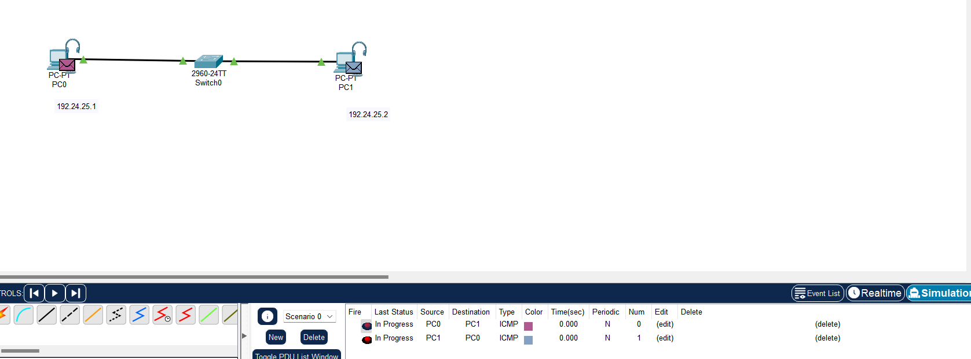

**Result:** Thus a Multimedia Network in Cisco Packet Tracer is simulated successfully.